Question: Which of the following evidences support Alfred Wegener's Continental Drift Theory?
1. The presence of identical fossil species on continents now separated by oceans.
2. The matching coastlines of South America and Africa.
3. The presence of similar glacial deposits in present-day tropical regions.
4. The discovery of mid-oceanic ridges and sea-floor spreading.
Select the correct answer using the code given below:
a) 1, 2, and 3
b) 1 and 4 only
c) 2, 3, and 4
d) 1, 2, 3, and 4
Answer: a
Explanation:
Statement 1 is correct: "The identical fossil plants in North American and European coal deposits could be explained if the two continents had been connected. Additionally, Mesosaurus fossils found only in South Africa and the Iraver formations of Brazil as evidence for the theory.
Statement 2 is correct: The jigsaw fit of the shapes of South America and Africa supports the theory of continental drift. Other examples include the fit between Greenland and Ellesmere and Baffin islands and the east coast of Africa, Madagascar and India.
Statement 3 is correct: The paleoclimatic evidence, such as the widespread glaciation from 380 to 250 million years ago and tillite deposits, was evidence supporting the theory which indicates that regions now in tropical climates were once subjected to glaciation, implying a different position of the continents in the past.
Statement 4 is incorrect: While mid-oceanic ridges and sea-floor spreading are important concepts in understanding plate tectonics, they were not part of Wegener's original theory. It was a part of Harry Hess's sea floor spreading the theory that came about in 1960, after Wegener's continental drift theory was proposed in 1912. Additionally, the concept of a passive ocean floor in Wegener's theory was proven incorrect by the sea floor spreading theory
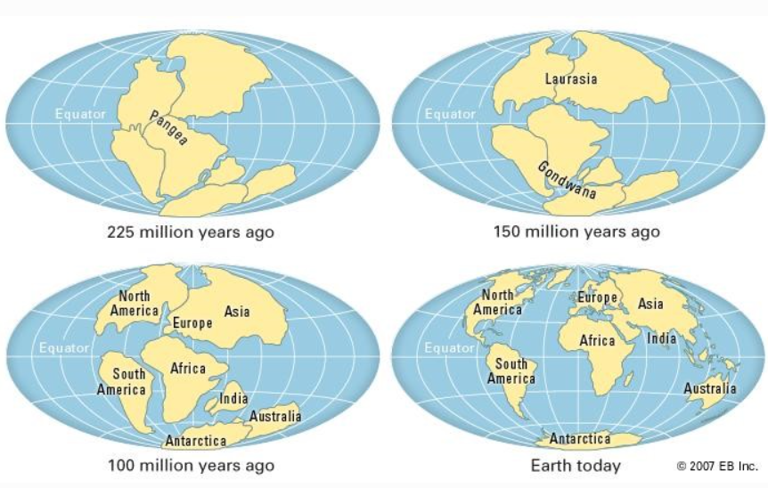

Difficulty: Moderate

Question: Consider the following informations:
Plate Boundary | Example | Feature
1. Divergent | Mid-Atlantic Ridge | Creation of new crust, volcanic activity
2. Convergent | Himalayas | Formation of fold mountains
3. Transform | San Andreas Fault | Horizontal displacement of crust
In how many of the rows given information is correctly matched ?
a) Only one
b) Only two
c) All three
d) None
Answer: c
Explanation:
Row 1 is correctly matched: The divergent boundaries are where plates move away from each other, leading to the creation of new crust, often associated with volcanic activity. The Mid-Atlantic Ridge is a classic example of this type of boundary.
Row 2 is correctly matched: The convergent boundaries are areas where plates collide, and this collision can lead to the formation of fold mountains. The Himalayas are specifically mentioned as an example of a mountain range formed by the collision of the Indian and Eurasian plates.
Row 3 is correctly matched: The transform boundaries are where plates slide past each other horizontally, without the creation or destruction of lithosphere. The San Andreas Fault is given as a prime example of this type of boundary.

Difficulty: Moderate

Question: Consider the following statements about Weathering and Erosion:
1. Mass wasting is an endogenic process.
2. Rainfall contributes to both Physical and chemical weathering.
3. Humans are an agent of Weathering.
Which of the statements given above are correct?
a) 1 and 2 only
b) 1 and 3 only
c) 2 and 3 only
d) All of the above.
Answer: c
Explanation:
- Statement 1 is incorrect: Mass Wasting is an exogenic geomorphic process. It is defined as the down slope movement of rock and soil mainly due to the force of gravity or the rapid or gradual sinking of the Earth's ground surface in a predominantly vertical direction. The most common mass-wasting types are falls, rotational and translational slides, flows, and creep.
- Statement 2 is correct: Rainfall aids physical weathering (through alternate wetting and drying, freeze–thaw action) and chemical weathering (through solution, oxidation, and hydrolysis), thus contributing to both.
- Statement 3 is correct: Humans are the biological agent of weathering. They are an important component of the weathering cycle of the earth. Many activities of humans influence the weathering of the rocks such as Mining, quarrying, burning of fossil fuels, etc.
Difficulty: Moderate

Question: Consider the following pairs:
1. Fold mountains - Orogenetic force
2. Continent building - Eustatic forces
3. Balancing of landforms - Isostatic forces
How many of the above pairs are correctly matched?
a) Only one
b) Only two
c) Only three
d) All four
Answer: b
Explanation:
● Pair 1 is correctly matched: Fold mountains are the result of orogenetic forces which can be due to Plate tectonics movement and the corresponding Continent-Continent convergence, like Himalayas, Continent-Oceanic convergence, like Andes.
● Pair 2 is incorrectly matched: Continent building is the result of epeirogenic forces which is a type of endogenetic forces.
○ Eustatic forces refer to changes in the global sea level that affect the volume of water in the world's oceans uniformly. These changes are attributed to factors that influence the overall mass or distribution of water across the oceans, leading to a rise or fall in sea level on a global scale
● Pair 3 is correctly matched: Balancing of landforms is due to Isostatic forces. Isostasy is the state of balance, or equilibrium, which sections of the Earth's lithosphere (whether continental or oceanic crust) are thought ultimately to achieve when the vertical forces upon them remain unchanged.

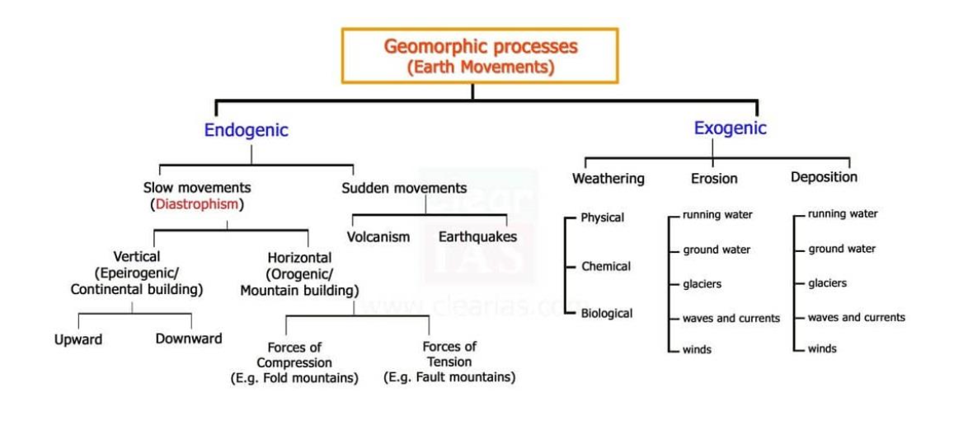

Difficulty: Tough

Question: Consider the following statements:
1. Chemical weathering is a slow and gradual decomposition process of rocks.
2. Weathering of rocks helps in the enrichment of certain ores.
Which of the statements given above is/are correct?
a) 1 only
b) 2 only
c) Both 1 and 2
d) Neither 1 nor 2
Answer: c
Explanation:
- Statement 1 is correct: • Chemical weathering is described as the extremely slow and gradual decomposition of rocks due to exposure to air and water. Chemical weathering is the process by which rocks decompose, dissolve or reduce them to a fine clastic state through chemical reactions.Chemical weathering can make a rock more vulnerable to physical weathering forces by weakening the components of the rocks. This makes the rocks easier to break up by mechanical means.
- Statement 2 is correct: The weathering of rocks is a natural phenomenon which may lead to concentration of certain ores and so the enrichment of various metal ores such as iron, manganese, aluminium, copper, etc., by leaching unwanted minerals leaving behind the valuable ones.

Difficulty: Moderate

Question: Identify the coastal landform based on the given information:
1. This landform is formed when sediment deposition connects an island to the mainland or another island.
2. It is created by wave action and longshore drift, gradually accumulating sand or gravel.
3. Over time, this feature may evolve into a permanent land bridge, altering local tidal patterns.
What is this type of landform?
a) Spit
b) Barrier Island
c) Tombolo
d) Estuary
Answer: c
Explanation:
Option a) is incorrect: A spit is a ridge of sand or shingle that is attached to the land at one end and extends into the sea or a bay. It doesn't typically connect two landmasses.
Option b) is incorrect: A barrier island is a long, narrow island that runs parallel to the coast and is separated from the mainland by a lagoon or bay. It does not connect to the mainland.
Option c) is correct: A tombolo is defined as a bar that connects an island to the mainland or another island. The provided description states the landform is created when "sediment deposition connects an island to the mainland or another island".Tombolos are formed through the accumulation of sand or gravel due to wave action and longshore drift. The description notes that the landform is "created by wave action and longshore drift, gradually accumulating sand or gravel".The description also points out that "Over time, this feature may evolve into a permanent land bridge, altering local tidal patterns." This accurately describes how a tombolo can become a more permanent feature.
Option d) is incorrect: An estuary is a coastal body of water where freshwater from rivers mixes with saltwater from the ocean.It is not a depositional landform.
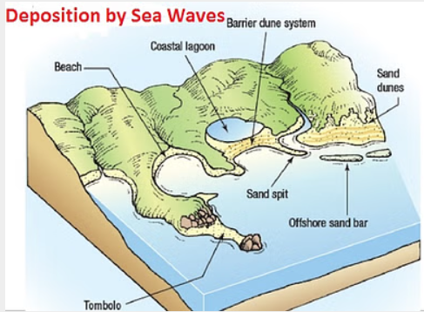

Difficulty: Moderate

Question: Which of the following volcanoes is/are correctly matched with their locations?
- Mount Cameroon - Rocky Mountains
- Mount Kilimanjaro - Andes Mountains
- Mount Pelee - Caribbean
Select the correct answer using the code given below:
a) 1 and 2 only
b) 1 and 3 only
c) 3 only
d) 1, 2, and 3
Answer: c
Explanation:
Pair 1 is incorrect: Mount Cameroon is located in West Africa. It is the only active volcano in West Africa. It is not located in the Rocky Mountains.
Pair 2 is incorrect: Mount Kilimanjaro is located in East Africa, along the East African Rift Valley. It is an example of a volcano in the East African Rift Valley. It is not located in the Andes Mountains, which are in South America.
Pair 3 is correct: Mount Pelee is located in the West Indies in the Caribbean Sea, specifically on the island of Martinique.

Difficulty: Moderate

Question: A lava plateau is discovered with extensive horizontal layers of basalt. What can be inferred about its formation?
a) It was formed due to explosive eruptions.
b) The lava had a high viscosity and solidified quickly.
c) It was created by highly fluid basaltic lava.
d) It was formed at a subduction zone.
Answer: c
Explanation:
Option a) is incorrect: Explosive eruptions typically produce pyroclastic materials and steep volcanic structures rather than extensive horizontal layers of basalt.
Option b) is incorrect: High-viscosity lava tends to form steep- conical volcanoes (like stratovolcanoes) and does not flow extensively to create horizontal layers. Therefore, this option is not consistent with the characteristics of a lava plateau.
Option c) is correct: It was created by highly fluid basaltic lava spreading over a large area- This is the most plausible explanation. Basaltic lava is typically low in viscosity, allowing it to flow easily and spread out over large distances, forming extensive horizontal layers characteristic of lava plateaus.
Option d) is incorrect: It was formed at a subduction zone- While some basalt can be associated with subduction zones, the formation of extensive horizontal basalt layers is more indicative of flood basalts or shield volcanoes, which are typically associated with hot spots or rift zones rather than subduction zones.

Difficulty: Moderate

Question: Consider the following informations:
Landform | Process | Location
1. Cirque | Glacial Erosion | Himalayas
2. Delta | Wind Deposition | Sundarbans
3. Doline | Karst Topography | Croatia
In how many of the above rows information is correctly matched?
a) Only one
b) Only two
c) All three
d) None of the above
Answer: b
Explanation:
Row 1 is correct: Cirques are erosional landforms created by glacial activity. They are bowl-shaped, amphitheater-like depressions found in mountain regions shaped by the action of glaciers. The Himalayas, with their significant glacial activity, would be a location where cirques can be found, so this is a correct match.
Row 2 is incorrect: Deltas are formed by the deposition of sediments by a river where it enters a larger body of water. They are a result of fluvial processes, not wind deposition. The Sundarbans is an example of a delta formed by the Ganges, Brahmaputra, and Meghna rivers. Therefore, this is an incorrect match.
Row 3 is correct: Dolines are a characteristic feature of karst regions, which are areas with soluble rocks like limestone or dolomite. Dolines are also called sinkholes or swallow holes, which are formed by the dissolution of carbonate rocks. Croatia has significant karst topography and is home to dolines. Thus, this is a correct match.

Difficulty: Tough

Question: Consider the following statements:
1. Coastal landforms result from the combined action of waves, tides, and currents.
2. Sea cliffs, stacks, and arches are formed by erosion rather than deposition.
3. Marine erosion is most effective along coastlines with resistant rock formations.
Which of the statements given above are correct?
a) 1 and 2 only
b) 1 and 3 only
c) 1 only
d) 1, 2, and 3
Answer: a
Explanation:
Statement 1 is correct: Coastal landforms are shaped by the dynamic interaction of waves, tides, and currents. Waves are noted as the most powerful agent of coastal erosion. Currents help to move eroded debris and deposit it as silt, sand and gravel along the coasts. The combined action of these forces results in both erosion and deposition along coastlines.
Statement 2 is correct: sea cliffs, stacks, and arches are classic erosional landforms, not depositional ones.
- Sea cliffs are formed by the constant pounding of waves against the coast, which leads to undercutting and the eventual collapse of the rock face.
- Stacks are isolated rock formations that remain after the collapse and erosion of cliffs or headlands.
- Arches are created when waves erode through a headland, forming a bridge-like structure. These features are the result of the removal of material, not the accumulation of it.
Statement 3 is incorrect: Marine erosion is most effective along coastlines with resistant rock formations. This statement is incorrect. Marine erosion is more effective along coastlines with less resistant rocks. Coastlines with varying rock resistance experience differential erosion, where softer rocks erode more easily, forming bays, while harder rocks remain as headlands. Well-jointed and fractured rocks are more easily eroded by waves. Areas with less resistant rocks like clays and shales tend to have weaker cliffs, while more resistant rocks like limestone and horizontally bedded sandstones form resistant cliffs.

Difficulty: Moderate

Question: Regarding volcanic activity, consider the following statements:
1. The Pacific Ring of Fire accounts for nearly 75% of active volcanoes.
2. The Mid-Atlantic Ridge is devoid of volcanic activity due to its divergent plate nature.
3. The East African Rift Valley has both active and dormant volcanoes.
Which of the statements given above are correct?
a) 1 and 2 only
b) 1 and 3 only
c) 2 and 3 only
d) 1, 2, and 3
Answer: b
Explanation:
Statement 1 is correct: Circum-Pacific region, also known as the Pacific Ring of Fire, hosts the majority of the world's active volcanoes. One source estimates it includes two-thirds of the world's volcanoes, and another source states that 75% of active volcanoes are located in the Pacific Ring of Fire.
Statement 2 is incorrect: The Mid-Atlantic Ridge is a zone of significant volcanic activity. This is because the Mid-Atlantic Ridge is a divergent plate boundary, where plates move apart and magma rises to the surface, creating a new crust. This process leads to fissure eruptions and the formation of new basaltic crust. One source mentions that about 15% of the world's active volcanoes are found along the constructive plate margins of mid-oceanic ridges. Iceland, which sits on the Mid-Atlantic Ridge, is cited as a prominent example of volcanic activity in this region.
Statement 3 is correct: The East African Rift Valley is a region with volcanic activity. Some volcanoes in this area, such as Mount Kilimanjaro and Mount Kenya, are likely extinct, while others might be dormant or have a history of activity. Some volcanoes are found along the East African Rift Valley, but these are probably extinct, suggesting that while there may be some dormant volcanoes, they are not actively erupting.

Difficulty: Moderate

Question: Concerning geysers and hot springs, consider the following statements:
1. Geysers are mostly found in tectonically active regions with magma chambers beneath.
2. Hot springs are characterized by continuous water flow, unlike geysers which erupt intermittently.
Which of the statements given above is/are correct?
a) 1 only
b) 2 only
c) Both 1 and 2
d) Neither 1 nor 2
Answer: c
Explanation:
Statement 1 is correct: Geysers are associated with volcanic activity and are generally located in areas with recent volcanism. They are found in regions where the earth's crust is relatively thin and where there is a heat source beneath the surface. The heat source is often a magma chamber or heated rocks at depth. Geysers are minor forms of the broader process of vulcanicity. The locations of geysers are confined to areas with active or recent volcanic activity, with most of the world’s geysers being confined to Iceland, the Rotorua district of North Island, New Zealand, and Yellowstone Park of the USA.
Statement 2 is correct: The key difference between hot springs and geysers is their pattern of water discharge. Hot springs have a continuous flow of heated water to the surface, while geysers erupt intermittently, with periods of spouting followed by periods of inactivity. Geysers are a special type of hot spring that spouts hot water and vapor from time to time

Difficulty: Moderate

Question: Consider the following statements about fold mountains:
1. Fold mountains are mainly formed due to compressional forces acting on sedimentary rock layers.
2. All fold mountains exhibit active volcanic activity.
3. The Alps and the Himalayas are young fold mountains formed due to continent-continent collision.
Which of the statements given above are correct?
a) 1 and 2 only
b) 1 and 3 only
c) 2 and 3 only
d) All of the above
Answer: b
Explanation:
Statement 1 is correct: The folded mountains result from intense compressional forces that cause the buckling and folding of the Earth's crust, particularly affecting sedimentary rock layers. These forces can be generated by various Earth movements, including the convergence of tectonic plates. The process of orogeny, or mountain-building, involves severe folding of the crust.
Statement 2 is incorrect: Fold mountains can be associated with volcanic activity, they clarify that this is not a universal characteristic. Volcanic activity is more common in the Circum-Pacific fold mountain system and in regions with subduction zones. The Himalayas, for example, a significant fold mountain range, do not have volcanoes because they are formed by a continent-continent collision that doesn't involve subduction, which is necessary for magma generation. Many older fold mountains do not have active volcanoes.
Statement 3 is correct: Both the Alps and the Himalayas as examples of young fold mountains. These mountain ranges were formed during the Tertiary period by the collision of continental plates, specifically the collision of the Indian and Eurasian plates to form the Himalayas, and the collision of African and European plates to form the Alps. Young fold mountains are often found near active convergent plate boundaries.

Difficulty: Moderate

Question: Consider the following statements:
1. Block mountains are formed by faulting due to tensional forces in the Earth's crust
2. Rift valleys occur where tectonic plates move apart, leading to crustal thinning.
3. Rift valleys are associated with high-magnitude earthquakes and explosive volcanoes.
Which of the statements given above are correct?
a) 1, 2, and 3
b) 1 and 3 only
c) 2 and 3 only
d) 1 and 2 only
Answer: d
Explanation:
Statement 1 is correct: Block mountains (Horsts) are explicitly linked to faulting caused by tension. When the Earth's crust cracks, faulting takes place. Faulting may be caused by tension or compression. When the block enclosed by the fault remains as it is or rises, and the land on either side subsides, the upstanding block becomes the horst or block mountain.Faulting results in the formation of Block Mountains. They are also called fault block mountains since they are formed due to faulting as a result of tensile and compressive forces
Statement 2 is correct: Rift valleys are formed due to tensional forces that cause the crust to stretch and thin. This process results in the subsidence of a block of land between two parallel faults, creating a trough-like depression. The movement of plates away from each other is the underlying mechanism that leads to the formation of rift valleys. The East African Rift Valley is frequently cited as a classic example of this process.
Statement 3 is incorrect: While rift valleys can experience earthquakes and volcanic activity, though they are generally associated with normal faulting due to tensional forces rather than the compressional forces that often cause high-magnitude earthquakes. Rift valley volcanism is also described as typically fissure eruptions of alkaline basalt. Explosive volcanoes are more closely linked to convergent plate boundaries, where subduction occurs and where compressional forces are dominant. Already existing volcanic activity may cease at the time of rift valley formation, and that if rift valleys are formed by tensional forces, then magma upwelling should not stop, unless compressive forces are present.

Difficulty: Moderate

Question: Consider the following statements about types of rocks and their interactions:
1. Igneous rocks form from the solidification of molten magma.
2. Sedimentary rocks are formed through the compaction of sediments.
3. Metamorphic rocks originate when existing rocks undergo heat and pressure without melting.
4. Igneous rocks can transform directly into sedimentary rocks, bypassing weathering and erosion processes.
Which of the statements given above are correct?
a) 1, 2, and 3 only
b) 2,3 and 4 only
c) 1 and 3 only
d) All of the above
Answer: a
Explanation:
Statement 1 is correct: Igneous rocks as those that are formed from the cooling and solidification of molten rock, which is referred to as magma when it is below the Earth's surface and lava when it is on the surface. This process can occur either deep within the Earth's crust (plutonic rocks) or on the surface after volcanic eruptions (volcanic rocks).
Statement 2 is correct: Sedimentary rocks are formed from the accumulation of sediments over long periods, often under water. These sediments are derived from the weathering and erosion of pre-existing rocks, as well as from organic matter. The process of lithification, which includes compaction and cementation of these sediments, is what forms the sedimentary rock.
Statement 3 is correct: Metamorphic rocks are formed when existing rocks (igneous, sedimentary, or even other metamorphic rocks) are transformed by intense heat and pressure. This process, called metamorphism, involves the recrystallization and reorganization of minerals within the original rock without the rock actually melting. Metamorphic rocks can also be created by contact with hot magma.
Statement 4 is incorrect: In the rock cycle igneous rocks do not directly transform into sedimentary rocks. Instead, igneous rocks must first undergo weathering and erosion to form sediments. These sediments can then be transported, deposited, and lithified to form sedimentary rocks. Igneous rocks can also be transformed into metamorphic rocks through heat and pressure. The rock cycle is a continuous process through which old rocks are transformed into new ones, often moving through multiple forms.
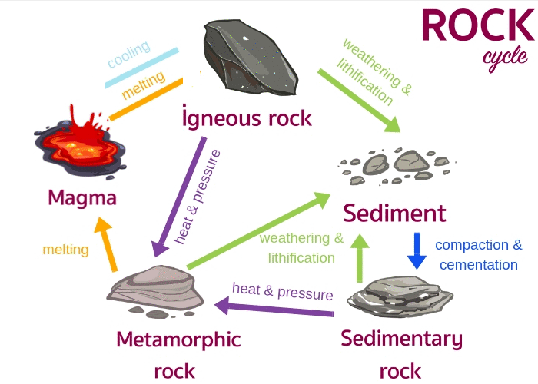
Difficulty: Moderate

Question: Consider the following statements about Subduction Zones:
1. They occur where an oceanic plate collides with and sinks beneath a continental plate.
2. Subduction zones often produce deep-sea trenches.
3. They are associated with the formation of large shield volcanoes.
4. The Mariana Trench is an example of a subduction zone.
Which of the statements given above are correct?
a) 1, 2, and 3 only
b) 1, 2, and 4 only
c) 2, 3, and 4 only
d) All of the above
Answer: b
Explanation:
Statement 1 is correct: Subduction zones are formed at convergent plate boundaries, where an oceanic plate collides with and is forced to descend or sink beneath a continental plate. This process of one plate sliding under another is called subduction. Subduction also occurs where two oceanic plates converge.
Statement 2 is correct: Deep-sea trenches are a characteristic feature of subduction zones. As the denser plate is forced downward into the mantle, it creates a deep depression in the ocean floor. These trenches are often the deepest parts of the ocean.
Statement 3 is incorrect: Shield volcanoes are typically formed by effusive eruptions of basaltic lava, and are mainly found at constructive plate boundaries and hotspots. Subduction zones are associated with explosive volcanic eruptions due to the melting of the subducted plate and the upward movement of magma. The volcanoes found at subduction zones are often composite volcanoes or island arcs, not shield volcanoes.
Statement 4 is correct: The Mariana Trench is an example of a deep-oceanic trench, which occurs at a subduction zone. It is one of the deepest known ocean trenches. The Mariana trench is located near Guam Island.

Difficulty: Moderate

Question: Consider the following statements:
1. Deep gorges are primarily formed by Glacial erosion.
2. Parallel mountain ranges are typically a result of Folding or faulting due to tectonic plate movement.
3. Mount Fuji in Japan is a volcanic mountain.
How many of the statements given above are correct?
a) Only one
b) Only two
c) All three
d) None
Answer: b
Explanation:
Statement 1 is incorrect: While glaciers can create valleys, deep gorges are primarily formed by fluvial erosion, which is the downcutting action of rivers. The
rivers in their youth stage carve deep, narrow V-shaped valleys and gorges.
Statement 2 is correct: The parallel mountain ranges are typically a result of folding and faulting due to tectonic plate movement. The young fold mountains are found near active converging plate boundaries. Example: The Himalayas (Fold Mountains) and the Western & Eastern Ghats (Fault-block mountains).
Statement 3 is correct:Mount Fuji in Japan is a volcanic mountain, formed due to successive volcanic eruptions at a convergent plate boundary where the Pacific Plate subducts beneath the Eurasian Plate.

Difficulty: Moderate

Question: Arrange the following stages of the Fluvial Cycle of Erosion in the correct sequence:
- Meandering stage with oxbow lakes formation
- Formation of V-shaped valleys and waterfalls
- Development of peneplain with residual hills

Select the correct answer using the code given below
a) 1-2-3
b) 2-1-3
c) 2-3-1
d) 3-1-2
Answer: b
Explanation:
Event 2: Youthful stage of the fluvial cycle. During this stage, rivers actively engage in downcutting, also called vertical erosion or valley incision, resulting in deep, narrow, V-shaped valleys. Waterfalls and rapids are common features as the river erodes the landscape. Pothole drilling is a significant process during this stage.
Event 1: Meandering stage with oxbow lakes formation is a characteristic feature of the late mature to old stages of the fluvial cycle. Rivers develop highly meandering courses with loops. Oxbow lakes are formed when meander loops are cut off from the main river channel due to lateral erosion and deposition.
Event 3: Development of the peneplain with residual hills represents the old stage or the end-product of the fluvial cycle. The landscape is reduced to a low, almost featureless plain with some low resistant remnants called monadnocks. Lateral erosion is very active during the old stage and leads to the formation of peneplains. The divides between drainage basins are lowered, and the relief is greatly reduced.
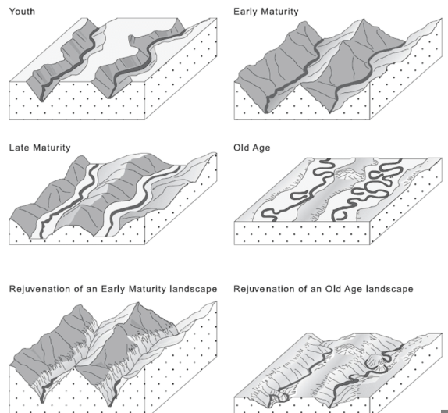
Difficulty: Moderate

Question: Consider the following pairs:
Agent of Erosion Associated Landform
1. Wind Yardang
2. River U shaped valleys
3. Glaciers Moraines
Which of the pairs given above is/are correctly matched?
a) 3 only
b)1 only
c) 1 and 3 only
d) All of the above
Answer: c
Explanation:
Pair 1 is correct: Wind (Aeolian erosion) forms landforms like Yardangs — elongated ridges sculpted by wind abrasion and deflation in arid deserts. The harder rock layers resist erosion, while the softer layers are eroded away, giving a streamlined shape aligned with prevailing winds.
Pair 2 is incorrect: Rivers typically create V-shaped valleys through vertical erosion during their youthful stage. In contrast, U-shaped valleys are formed by glacial erosion, as glaciers carve out deep, broad troughs by plucking and abrasion.
Pair 3 is correct: Glaciers form Moraines, which are accumulations of rock debris (till) deposited along the edges, middle, or terminus of a glacier. They are depositional features created as the glacier melts and loses its capacity to carry sediment.
Difficulty: Tough

Question: In the context of Endogenic Forces, consider the following statements:
1. Epeirogeny is a mountain building process whereas Orogeny is continental building
process.
2. Diastrophic movements are gradual and very slow in nature.
3. Endogenic forces are usually driven by atmospheric forces.
Which of the statements given above is/are incorrect?
a) 1 and 2 only
b) 2 only
c) 1 and 3 only
d) 2 and 3 only
Answer: c
Explanation:
Statement 1 is incorrect: Orogenic processes involve mountain building through severe folding and deformation of the crust, leading to structural and compositional changes. In contrast, epeirogenic processes involve the broad uplift or warping of large portions of the Earth’s crust, contributing to continental formation rather than mountain building.
Statement 2 is correct: Diastrophic movements are gradual and can extend over thousands of years. These movements cause slow changes that may not be noticeable within a human lifetime.
Statement 3 is incorrect: Endogenic (or endogenetic) forces originate from within the Earth, such as tectonic or volcanic forces. Exogenic forces, on the other hand, are driven by external factors like gravity, wind, water, and atmospheric processes.
Difficulty: Moderate

Question: Sliding of a mass of rock or soil along a curved surface in a rotational form is known as:
a) Mud flow
b) Landslide of rocks or soil
c) Creeping of rocks or soil
d) Slump of rocks or soil
Answer: d
Explanation:
- Flow is defined as downslope movement of rock, soil, or debris due to gravity. Examples - mudflows, debris flows, and rock flows.
- Slide is the movement of rock, soil, or debris down a slope due to the force of gravity. This movement is typically characterised by a distinct sliding motion. Example - landslides.
- Slump refers to the downward sliding or slipping of a mass of rock or unconsolidated material along a curved surface. It often occurs in cohesive materials like clay and is characterised by the rotation of the sliding mass. Example - after heavy rainfall slump along slopes of Western Ghats. Hence, it is the correct answer.
- Creep refers to the slow and gradual downslope movement of soil or regolith. It involves the imperceptible movement of particles over time due to the force of gravity. Creep is often characterised by the bending or tilting of objects on a slope.

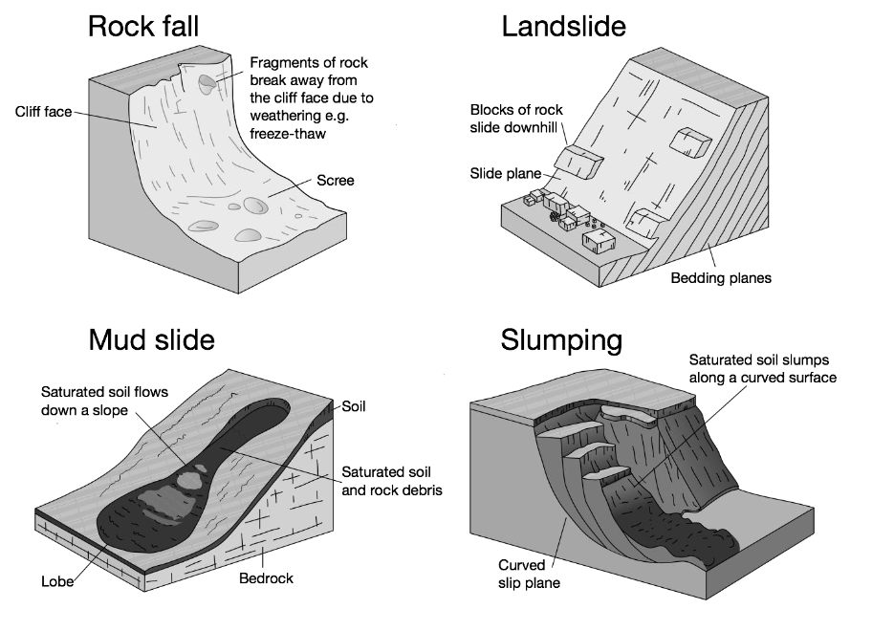

Difficulty: Moderate

Question: Consider the following statements:
1. Solifluction happens most in mountainous places where a long dry season is followed by heavy rains.
2. Rock slides happen in mountainous regions where mining is done.
3. Undercutting of steep slopes can trigger Mass Movements.
Which of the statements given above is/are correct?
a) 1 only
b) 1 and 3 only
c) 2 and 3 only
d) All of the above
Answer: c
Explanation:
- Statement 1 is incorrect: Solifluction is progressive movement of a mass down a slope ("mass wasting") as a result of the freeze-thaw activity.
It can also be defined as a type of creep that occurs in cold regions or at high elevations and occurs when the mass of saturated rock waste flows down the slope.
Solifluction peaks during the late spring and summer months when soils are saturated by thaw. Increased pore pressures in saturated soils result in unstable circumstances due to a lack of friction and cohesiveness.
Solifluction can occur on slopes of less than 1 degree, but it is more common on slopes of 5 to 20 degrees.
Thus, statement is not correct. Instead, it is Mudflows which refers to the fast-moving flows of mud and rock. Mudflows occur mostly in mountainous places where a long dry season is followed by heavy rains. Their high speeds and the destructive volume of the mudflows make them dangerous to life and property.
- Statement 2 is correct: A rock slide is a type of landslide which occurs when a mass of rock moves quickly downslope. They occur in the mountainous regions or where excavation activities are undertaken such as mining and quarrying etc. Deep excavation of earth loosens the land which is the cause of landslides in excavation sites. A rockslide can also occur after a heavy rainfall.
- Statement 3 is correct: A mass movement can occur any time a slope becomes unstable. Undercutting of steep slopes causes instability of the slopes.
Difficulty: Moderate

Question: X is one of the weathering processes in which thermal expansion and contraction takes place. X results in flaking of rocks and sheets and is common in arid and semi-arid regions. Identify X.
a) Frost wedging
b) Abrasion
c) Exfoliation
d) Oxidation
Answer: c
Explanation:
- Exfoliation is the process of flaking off of more or less curved sheets of shells from over rocks or bedrock, resulting in smooth and rounded surfaces. It can occur due to expansion and contraction induced by temperature changes. Exfoliation domes and tors result due to unloading and thermal expansion respectively. Eg. In deserts. Hence, it is the correct answer.
- Frost wedging is a type of mechanical weathering process that occurs in cold climates where temperatures regularly fluctuate above and below freezing. It involves the repeated freezing and thawing of water within the cracks and pores of rocks, leading to the expansion and eventual fragmentation of the rock. Eg. In Himalayas, Alps etc.
- Abrasion is the process in which rocks can be broken up by friction and continuous impact with other rock pieces during transportation. Namely, a rock fragment carried along in the raging currents of a river continuously rubs itself against other fragments and the river bed.
- Oxidation is a chemical process. This process involves the reaction of minerals with oxygen, leading to changes in their composition. The most common minerals affected by oxidation are those containing iron.
Difficulty: Moderate

Question: Consider the following statements:
1. Karst topography is produced due to the chemical weathering.
2. The action of endogenic forces is uniform throughout the earth.
3. Weathering is considered as first stage of the production of soils.
Which of the statements given above is/are correct?
a) 1 and 2 only
b) 2 and 3 only
c) 1 and 3 only
d) 3 only
Answer: c
Explanation:
- Statement 1 is correct: Karst topography refers to the natural features produced due to the chemical weathering or slow dissolving of limestone, dolostone, gypsum, etc. The chemical weathering agent is slightly acidic groundwater that begins as rainwater which has excavating effects on massive soluble limestone. It is characterized by underground drainage systems with sinkholes and caves.
- Statement 2 is incorrect: There are differences in geothermal gradients and heat flow from within the earth and the strength and crustal thickness, therefore, the action of endogenic forces is uneven.
- Statement 3 is correct: Weathering is considered the first and fundamental stage in soil formation, as it disintegrates and decomposes parent rocks into finer mineral particles. These weathered materials later mix with organic matter (humus), water, and air, gradually developing into mature soils with distinct soil horizons (A, B, C). Without weathering, the raw material required for pedogenesis would not exist.
Difficulty: Moderate

Question: Consider the following pairs:
Landform Characteristics
1. Spits : Erosional landforms
2. Kames : Depositional landforms
Which of the pairs given above is/are incorrectly matched?
a) 1 only
b) 2 only
c) Both 1 and 2
d) Neither 1 nor 2
Answer: a
Explanation:
Pair 1 is Incorrect: A spit is a depositional landform that forms in coastal environments through the movement of sediment by longshore drift. It is a narrow, elongated stretch of land that extends from the mainland into the sea or across the mouth of an estuary. Spits are often composed of sand or gravel, and their formation is influenced by the action of waves, currents, and tidal forces.
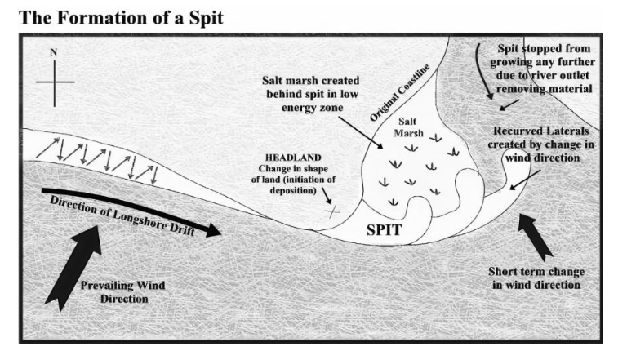
Pair 2 is Incorrect: Kames are depositional glacial landforms. They are irregularly shaped mounds or hills composed of sand, gravel, and till deposited by meltwater streams flowing within or beneath glaciers. When the ice melts, these sediments are left behind as isolated mounds. Kames are often found in association with other glacial features like eskers and kettle holes.
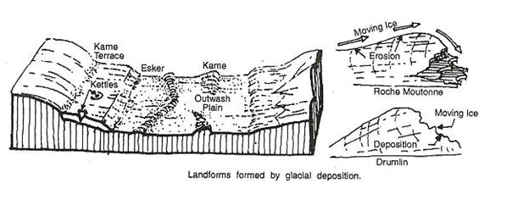
Difficulty: Moderate

